FORM 2 CHEMISTRY MARKING KEY
SECTION A

- A
- B
- D
- C
- D
- B
- B
- B
- B
- C
- B
- B
- B
- C
- B
- C
- A
- A
- B
- B

SECTION B (50 MARKS)
Answer all the questions in the spaces provided
- a. Differentiate between a derived quantity from a basic quantity _
-Derived quantity are units obtained from the combination of basic units (1M) while basic units are set of unrelated units that form the basis of the SI units.(1M)
- Why are most of the apparatus in chemistry laboratories made of glass?
-Glass is non-reactive, it doesn’t contaminate experiments, and its transparency allows scientist to clearly observe reactions. (2marks)
- a. State three uses of lithium metal
-Used in production of lubricating grease
-used in batteries which contain more energy compare to other metals
-used in deoxdising copper and copper alloys
-used in production of titanium
- Give three ways in which atoms attain stability.
-donating electroms
- gaining electrons
-Sharing electrons(3 marks)
- An element is represented as ${}_{13}^{27}X$.

- Draw the structure of the atom X

AI

(3marks)
- To which group of the periodic table does an atom X belong?
Group 3 (1 mark)
- Calculate the number of neutrons of atom X
No of neutrons ₌ mass no-atomic no
27-13= 14
- The figure 2 below shows a chemical bonding between sodium and oxygen
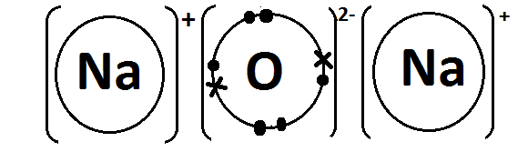

- Name the type of bonding shown above
-ionic bonding (1 mark)
- Give a reason to your answer.
-this is due to the transfer of electrons from the metal (sodium) to the non-metal (oxygen)
- State two ways of determining the strength of an acid. _ -using PH Scale
-using universal indicator(2 marks)
- List two advantages of local indicators in identifying acid and base
-they are cheap(economical)
-they are readily available
-they are non-toxic
-they are environmental friendly
- a. State ways of separating the following
  - ink =Chromatography
  - salt solution=Evaporation
  - petrol= Fractional distillation
- mention two ways of making saturated solution unsaturated
-By adding more solvent to the solution
-increasing the temperature of the solution e.g by heating
(2 marks)
- The equation shows the reaction between sodium metal and water
Na_{(s)} + H₂O_{(l)}  NaOH_{(aq)}+ H_{2(g)}
- What does (l) and (aq) mean in an equation above?
(l) ; L=Liquids
(aq) ; Aq=Aqueous
- Balance the equation
2Na_{(s)} + 2H₂O_{(l)} 2NaOH_{(aq)}+ H_{2(g)}
- If 60g of Na was used what would be the mass of NaOH produced. (RAM: Na = 23. O =16, H = 1)
- If 46g of Na produces 80g of NaOH
- 60g of Na=more
- 60g/46g×64g
- 104.3g
- Therefore 104.3g of NaOH would be produced (4 marks)
- a. (i) Define fractional distillation.
Is the process of separating different liquids from a mixture of miscible liquids (1mark)

(ii). Why is carbon dioxide and water removed first during fractional distillation of liquid air.
-this is because they freeze at higher temperatures than nitrogen and oxygen which would cause blockages in the fractional distillation equipment (2marks)
- Explain why element Cl is more electronegative than Element P
-Chlorine has 7 valence electrons needing only one more to complete its outer shell while phosphorus need 3 electrons. The higher effective nuclear charge and smaller atomic radius makes chlorine to be more electronegative
(3 marks)
- (a) Element oxygen contains 90% of ${}_{8}^{16}O$, and 10% of ${}_{8}^{ 18}O$. Calculate the Relative Atomic Mass of Oxygen.
solution
RAM=(90/100×16) +(10/100×18)
14.4 + 11.8
26.2 (3 marks)
- (b) Table below; Shows different types of substances.
Substance | type
Cocacola | Mixture
Water | Compound
Nitrogen | Element

- Complete the table by filling type substances as element, compound and mixture. (3marks)

- Give any one differences between a mixture and a compound.(1mark)
-a mixture is a substace that contains two or more kinds of substances that are not chemically joined while a compound is a pure substance made upof two or more different diffferent chemical lements
SECTION C (30 MARKS)
- a. Explain any two applications of neutralization reaction.
-toothpaste. tooth paste contains basic compounds that neutralize acids in the mouth helping to prevent tooth decay
-antacids.magnessium hydroxide neutralize excess stomach acids
- marks)
- Explain clearly how you can produce an acid -base indicator using Hibiscus fruits.
- collect hibiscous flowers and cut into small pieces
- place them in a hibiscus flowers crucible and add enough water to just cover the pieces
- boil gently in a crucible for 10 minutes
- cool the mixture
- put off liquid leaving the solid behind, record the colour
- add the solution to vinegar and record the natural colour in an acidic environment
- add the solution to sodium bicarbonate, shake and record the natural colour in an basic environment
(6 marks)

  - Explain how the reactivity of group VII elements differs from that of group I elements of the periodic table.
-group 1 reactivity increases down the group, while group group 7 reactivity decreases. This is because group 1 metals react by losing one electron and larger atoms lose electron more easily while group 7 reacts by gaining one electron and smaller atom attract the electron more easily.
(4 marks)
  - Using well balanced chemical equations, explain any two chemical properties of alkaline-earth metals
-they react with oxygen to produce oxides.
- Beryllium+oxygen=Beryllium Oxide+Hydrogen gas
- 2Be(s) +O2 =2BeO (s)
-they react with water
- Calcium +Water=Calcium hydroxide+Hydrogen gas
- Ca(s)+2H2O(l)=Ca(OH)2+H2(g)
-They react with dilute acids
- Sodium +Sulphuric Acid=Sodium Sulphate+Hydrogen gas
- Na(s) +H2SO4(aq)=NaSO4(aq) = H2 (g)(6 marks)
- With the aid of a well labelled diagram, describe how you can obtain pure water from the mixture of water and ethanol.
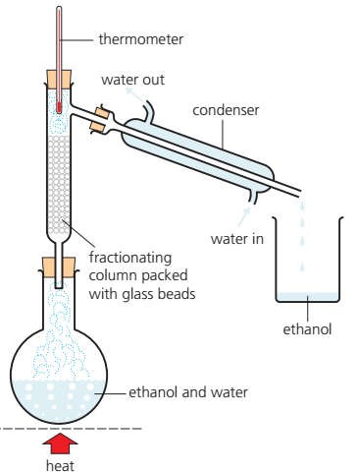

  - The mixture is heated. ethanol and water vapour rises up the tube
  - The vapor condenses in the glass beads in the column making them hot
  - When the temperature reaches 78 degrees, ethanol vapor moves up the tube into condenser while water drips back into the flask
  - Eventually the thermometer reading rises above 78 degrees. This indicates that all the water has been separated hence heating can be stopped

